Alice Springs Multicultural Centre
Dear stakeholder
The Northern Territory Government is celebrating community and connection by delivering a new multicultural centre in Alice Springs.
The Alice Springs Multicultural Centre (ASMC) will be an inclusive, purpose-built centre for Alice Springs’ multicultural community to gather, host events and share their unique cultural expressions with the broader community.

Located in the heart of the CBD within the Anzac Oval precinct the ASMC will include:
- flexible internal space for up to 200 people
- external covered open space for up to 200 people
- catering kitchen, toilets and amenities, a dedicated meeting room, and associated car parking.
- raised stage to allow for cultural performances or events
- ICT and CCTV services
Awareness of the nearby sacred site will be embedded in all stages of the design and construction of ASMC ensuring cultural sensitivity and environmental responsibility are core to the project.
Following design and approvals, construction is anticipated to commence in late 2026 and is expected to be complete by mid-2027.
Contact
To find out more about this project being delivered by DLI, contact sam.brown@nt.gov.au or visit dli.nt.gov.au/projects

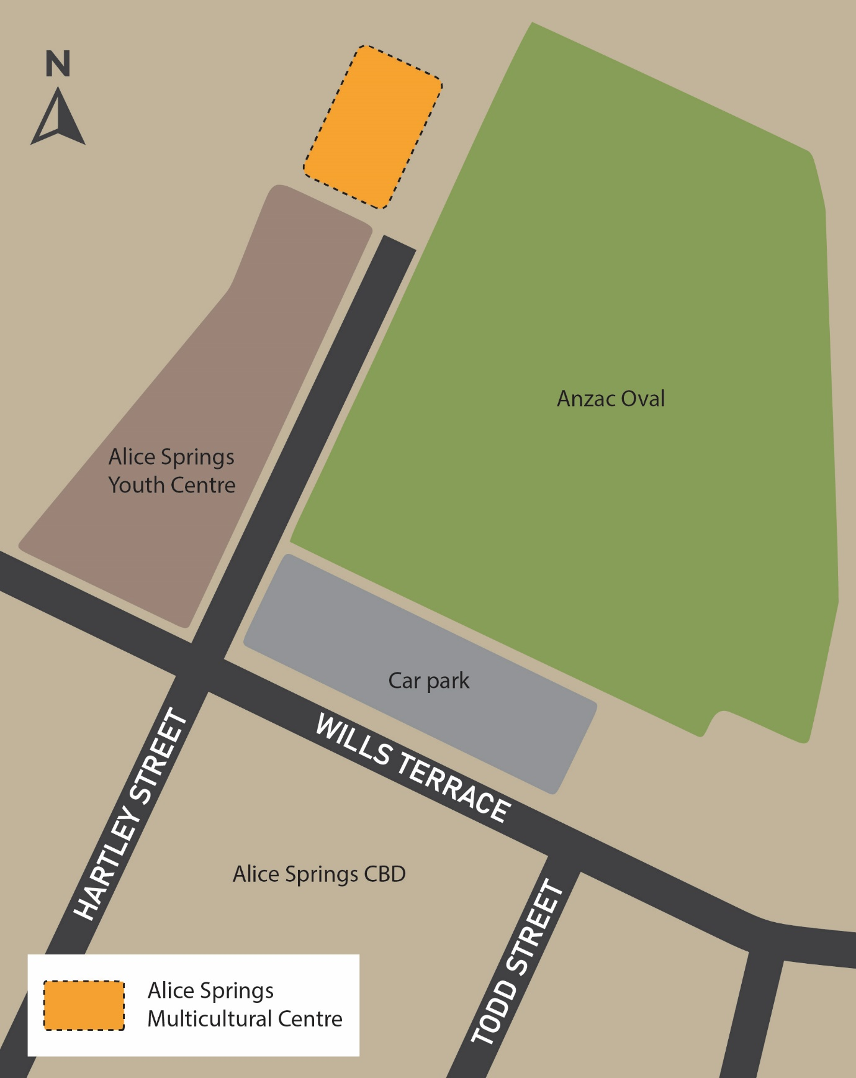
Image showing area of works

