Gillen Oval Multi-Sport Precinct development
Master plan release
Dear Stakeholder
The Northern Territory Government has released the master plan for the Gillen Oval
Multi-Sport Precinct in Alice Springs.
The master plan outlines a vision for a versatile community facility, including:
- a multipurpose large, irrigated greenspace adaptable for a wide range of youth sport (seasonal line marking, removable goals)
- school access: exclusive use during school hours
- culturally appropriate, inclusive and accessible change room and toilet facilities
- canteen, first-aid, drinking water, office and storage facilities
- increased car parking, bike racks, shade and landscaping to optimise available space
- pedestrian access to Jim McConville Oval.
The master plan reflects the needs and priorities of key stakeholders, considers community feedback and has been informed by relevant strategic documents to ensure sport-specific compliance and quality.
Located adjacent to the site currently known as Centralian Middle School, the development of the precinct will provide a versatile community facility, giving the school and local sporting codes enhanced playing and training grounds.
The next step is the development of detailed design for the site, in line with the master plan. Following detailed design, construction is expected to take 12 months to complete.
Contact
To find out more about this project delivered by DLI, contact sam.brown@nt.gov.au or visit dli.nt.gov.au/projects

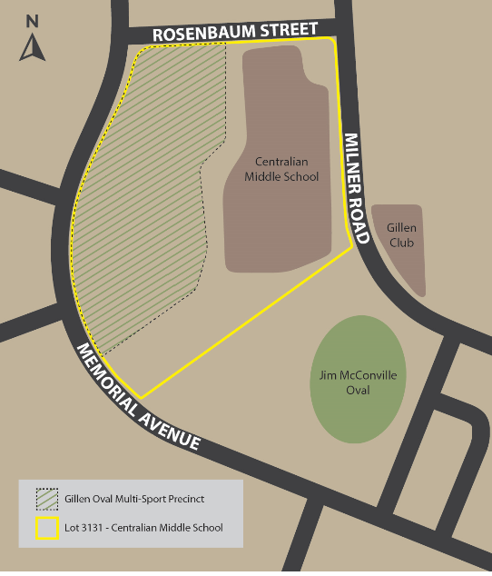
Image showing area of works

