Alice Springs Multicultural Centre
Tender award
Dear stakeholder
The Northern Territory Government has awarded a contract to Territory-based contractor Aspire Design and Construct Pty Ltd to design and construct the Alice Springs Multicultural Centre (ASMC), marking an important milestone for the project.
The $8.8 million contract is to undertake the detailed design and construction of the centre, supporting 155 jobs and Territory businesses.
The centre will be an inclusive, purpose-built centre for Alice Springs’ multicultural community to gather, host events and share their unique cultural expressions with the broader community.
Awareness of the nearby sacred site will be embedded in all stages of the design and construction of ASMC ensuring cultural sensitivity and environmental responsibility are core to the project.
Following design and approvals, construction is anticipated to commence in late 2026 and is expected to be complete by late 2027.
Contact
To find out more about this project being delivered by DLI, contact jason.reid@nt.gov.au or visit dli.nt.gov.au/projects

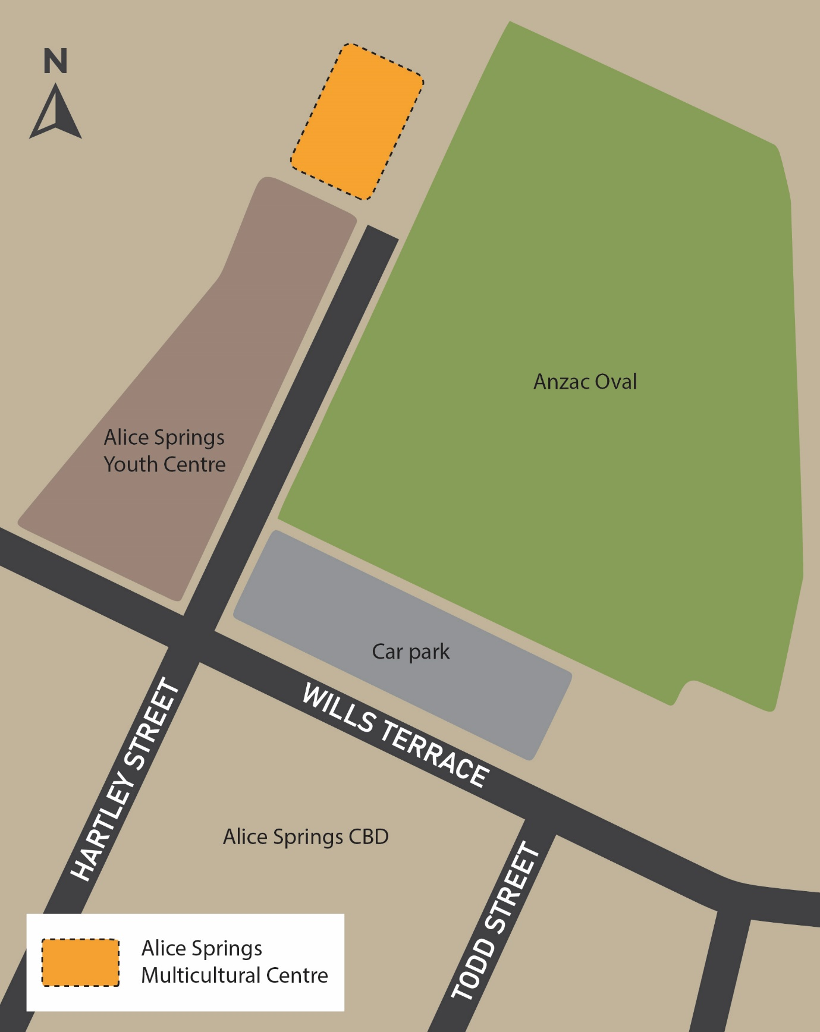
Image showing area of works

